1. Create index, other, relative. HTMLs . (Base .html will be used for inheritance later).

For example:

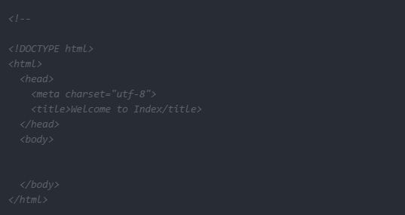

1. Create the views. py

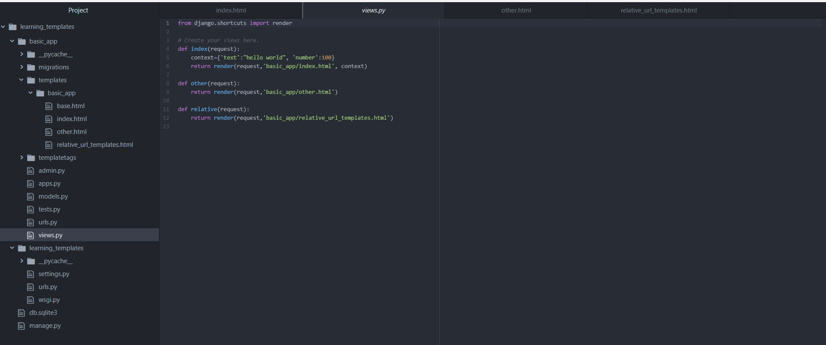

1. Set the URLs by going to the project urls.py

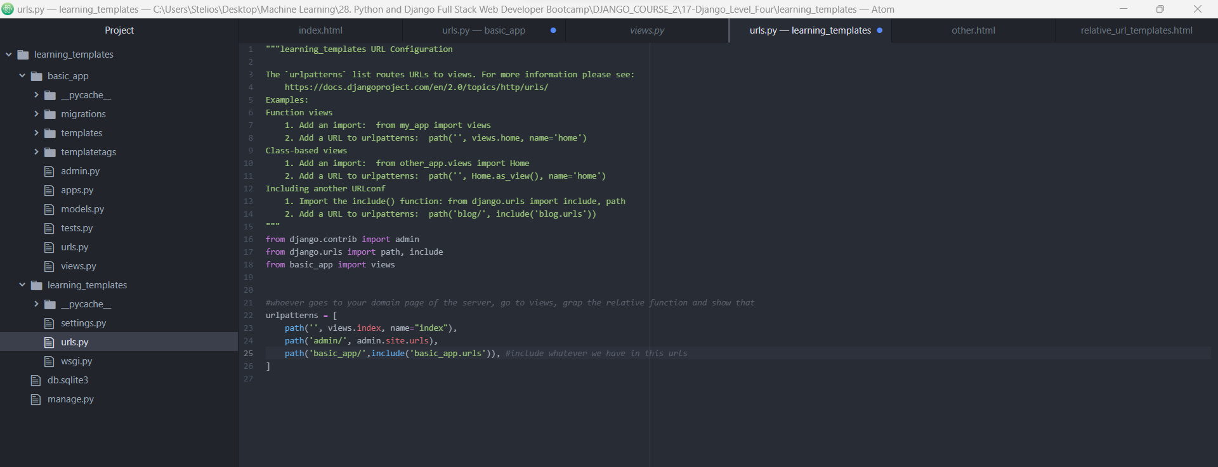

1. Use template tagging in the app URL.py (we use relative URLS, so that it can search inside the specific domain that we show).

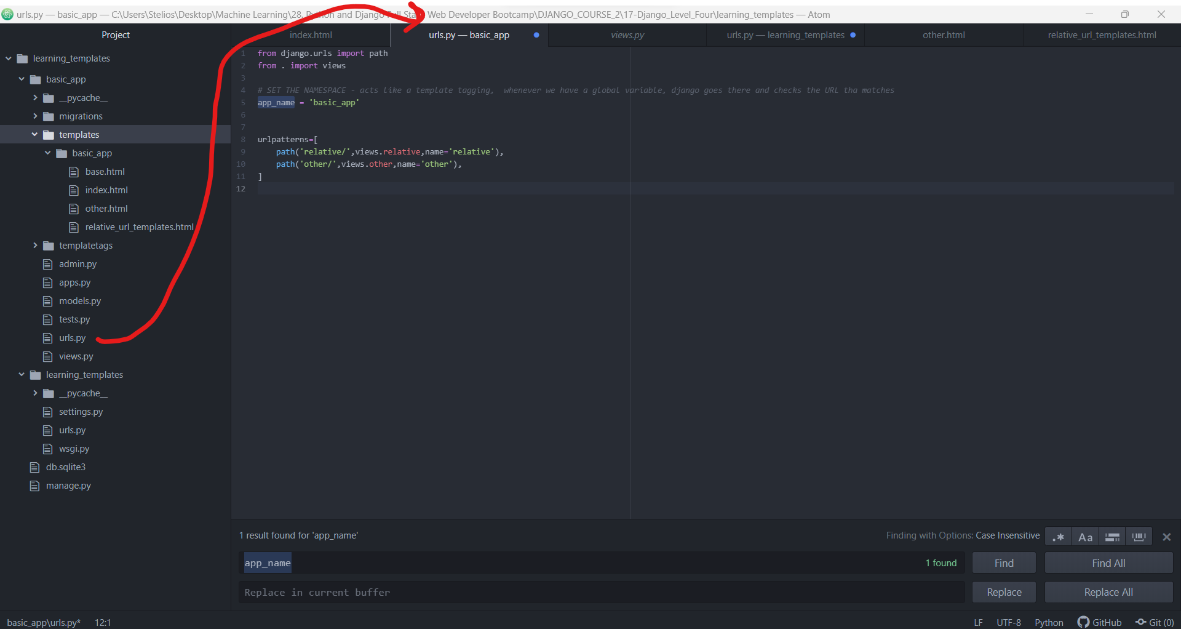

1. Change relative_URL.html so as to use the relative URLS

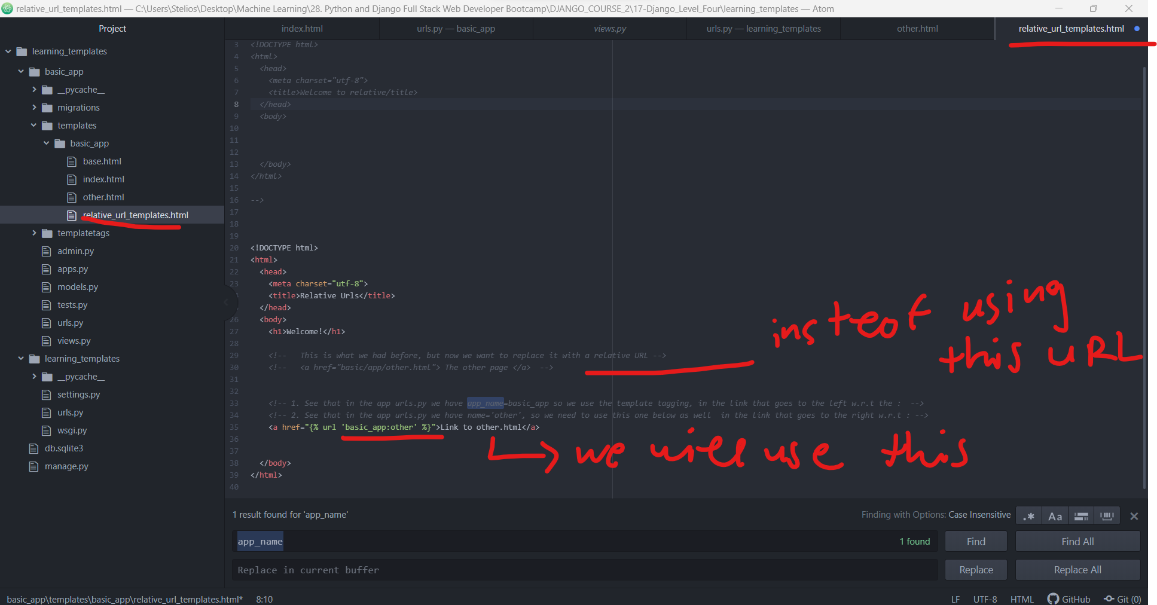

1. Admin is also an application and can be used for relative URLS.

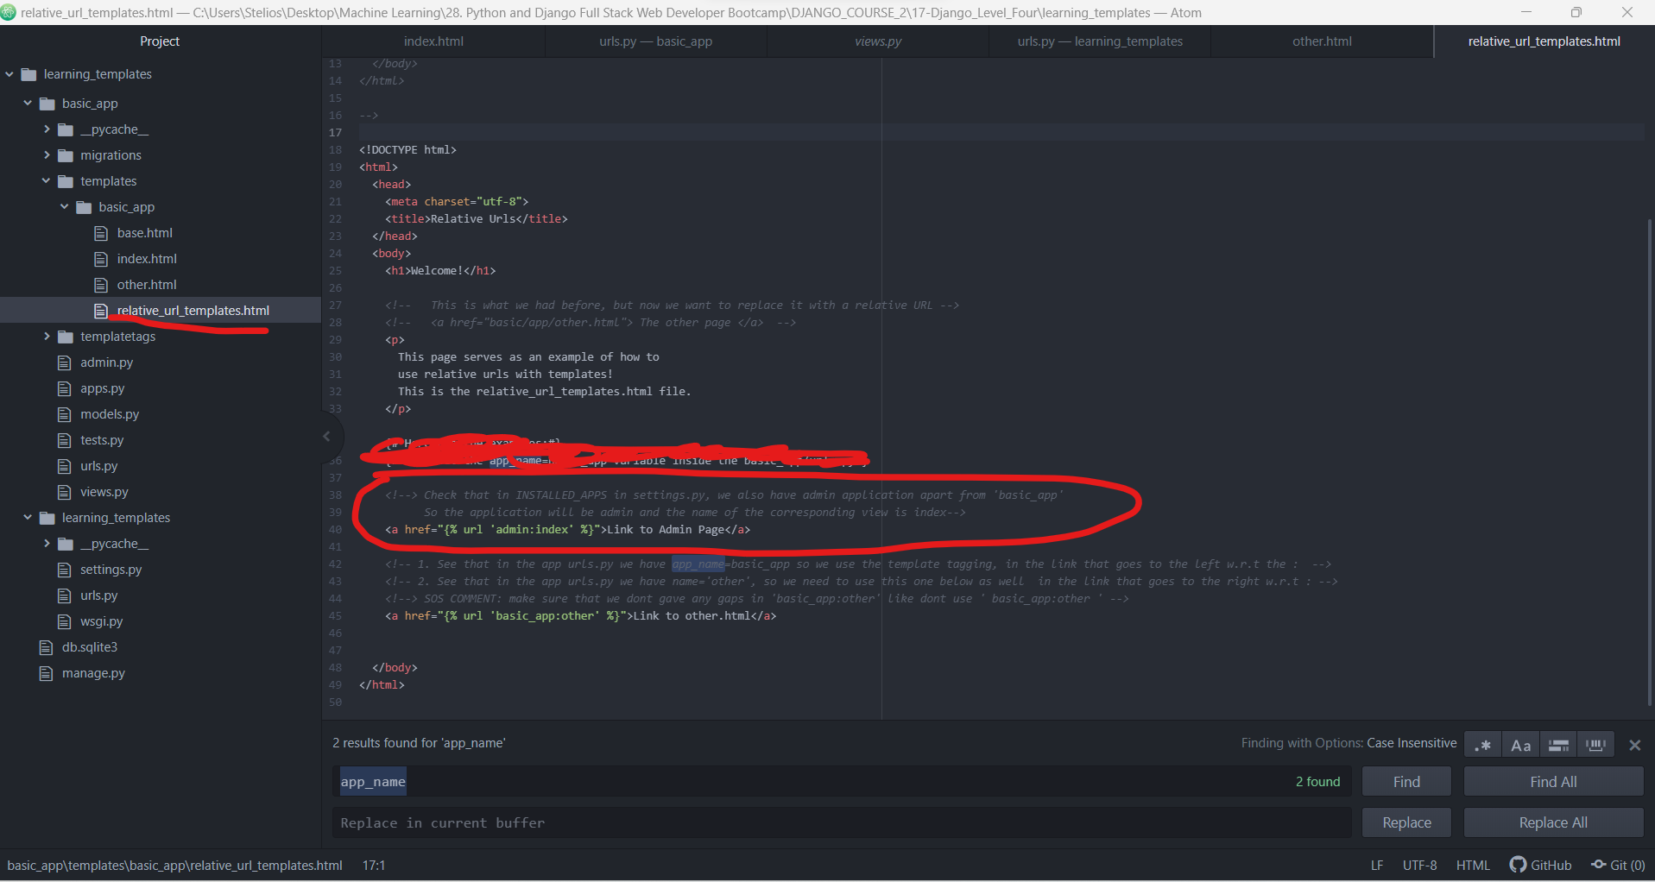

1. Run Server using “python manage.py runserver” in anaconda prompt. Also use python

